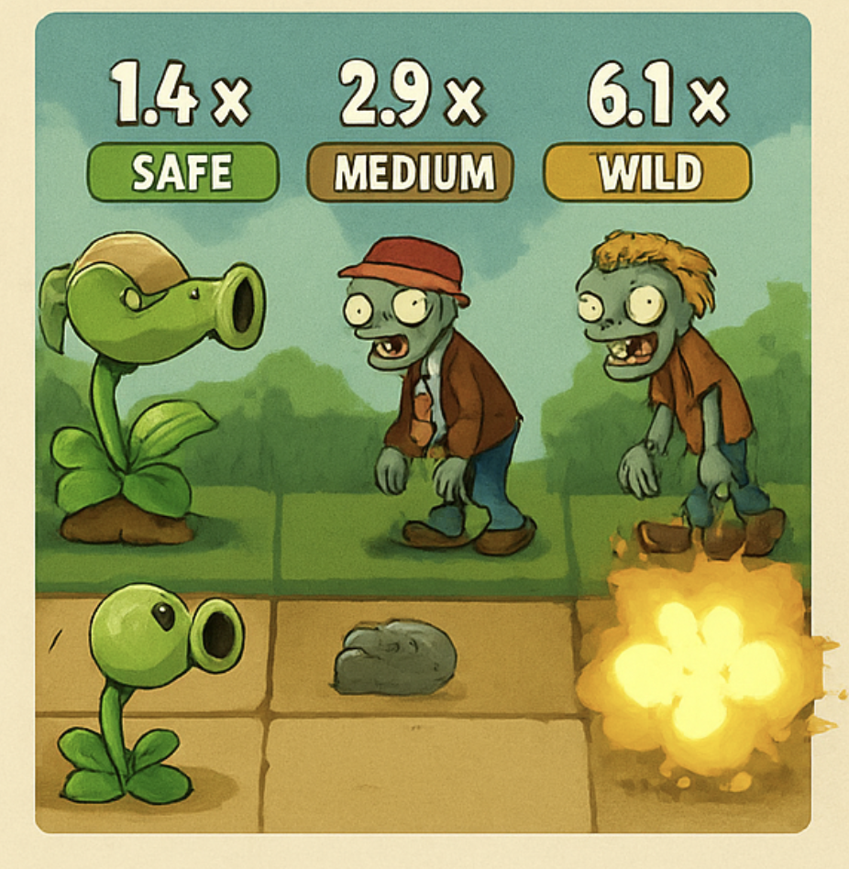

# **ZOMBIE RUSH – Overview**

# **A Social Multi-Lane Crash Game in a PvZ-Style World**

**Zombie Rush** is a fast, character-driven **3-lane Crash game** where players bet on cartoon zombies running attacking plants. Multipliers rise as zombies advance; players cash out before a zombie dies—or hold on for a rare jackpot when the zombie reaches the plants and eats it.

All players worldwide watch the **same synchronized round**, creating shared tension and strong social virality.

## 

## 

## **GAMEPLAY**

Each round takes place on three horizontal lanes set in themed worlds (Garden, Egypt, Wild West, etc.).

Plants on the left shoot **cosmetic projectiles**, and zombies run toward them.

### **Lane Types**

* **Slow** – Low volatility, slow multipliers, long survival.
* **Fast** – Balanced volatility, core lane.
* **Wild** – High volatility, explosive multipliers, frequent early death, Huge jackpot potential.

### **Round Flow**

1. **Soft-Start Bet Phase:**The player pre-sets stakes and selects 1–3 lanes; bets apply to next round automatically.
2. **Zombies run → Multipliers Rise:**Animation is cosmetic; multiplier curves follow lane math. Every lane has an independent RNG and curve.
3. **Cashout Anytime:**
   * Cash out while alive → win (stake × multiplier)
   * Zombie dies → loss
   * Zombie reaches plants → **JACKPOT**
4. **Energy Meter:**Fills as you play → periodic free rounds.

### **Round Cycle time**

* **Action:** ~7.0 s
* **Result / highlight:** ~1.5–2.0 s
* **Dedicated betting buffer:** ~2.0 s

**Total: ~10.5–11 seconds per cycle**

This is a good compromise:

* Fast enough to feel “arcade & dynamic”.
* Slow enough to:
  + Let 3-lane manual play be viable.
  + Make jackpots feel special.
  + Reduce latency complaints.
  + Give players breathing room to adjust bets.

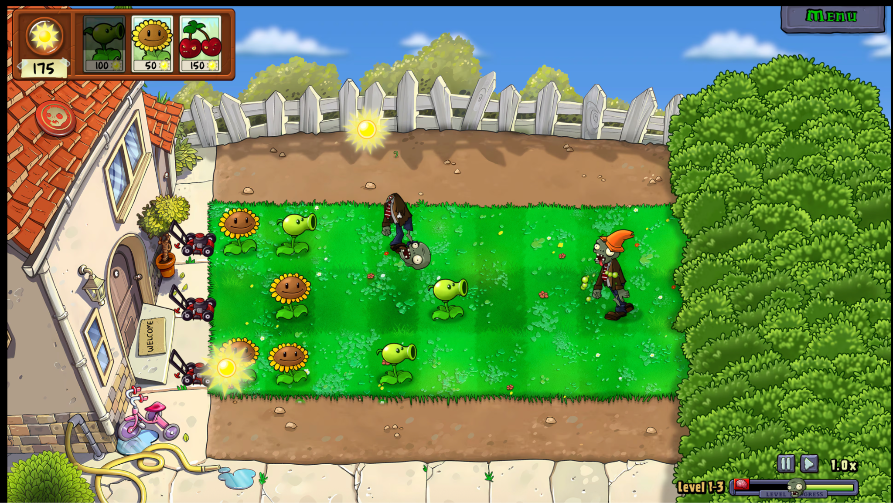

### **Lane parameters**

| **Lane** | **Max Multiplier** | **Probability Zombie Reaches Plant** | **“Feels like”** |
| --- | --- | --- | --- |
| Slow | ~4× | ~0.2–0.3% | Very safe, low ceiling |
| Fast | ~20× | ~0.7–1.2% | Main excitement lane |
| WILD | ~80× | ~1–2% | High drama, |

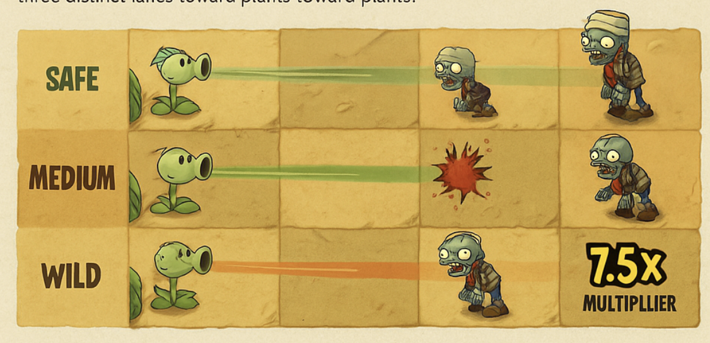

### **Approximate crash distribution**

**SAFE Lane**

* Crash < **1.2×**: ~25%
* Crash **1.2×–2×**: ~55%
* Crash **2–4×**: ~19.5%
* Reach **4×**: ~0.5%

Feels like:

* Many 1.2–1.8× wins if you cash early.
* Rarely goes above 3×, so not for jackpot chasers.

**MEDIUM Lane**

* Crash < **1.2×**: ~35%
* Crash **1.2×–3×**: ~40%
* Crash **3–10×**: ~23%
* Reach **10–20×**: ~2%

This lane is where most “wow” moments will happen in regular play.

**WILD Lane**

* Crash < **1.2×**: ~55%
* Crash **1.2×–5×**: ~30%
* Crash **5–30×**: ~12%
* Reach **30–80×**: ~3%

This makes Wild lane very “swingy”:

* Most rounds end early.
* But when it runs, it creates huge shareable moments.

### 

### 

### 

### 

### **Max Multiplier as Jackpot**

### Jackpot is simply the rare, fixed maximum multiplier that lane can reach.

### Mechanics:

### Each lane has a max multiplier:

### Slow: e.g. 4×

### Fast: e.g. 15×–20×

### Wild: e.g. 40×–80× (depending on math profile)

### When RNG says “this round is a max-multiplier round,” the zombie:

### Survives all the way to the plant

### Triggers the JACKPOT animation

### Payout is:

### Bet × max multiplier for that lane

### There is no separate pooled pot; it’s baked into the volatility curves.

### **Power Meter logic (per player)**

* Each time the player plays a **paid round** (at least one lane has a paid bet), the meter fills by 1 step.
* The meter has a fixed number of steps, e.g. **10 steps**.
* When the meter is full, the player gets **1 Free Round**.

Conceptually:

* You allocate a small part of the theoretical RTP to “fund” free rounds.
* For example:
  + Target base RTP (without free rounds): 95.0%
  + Real RTP including free rounds: 96.0%
* You do this by:
  + Slightly lowering base curve multipliers / jackpot frequency
  + The free rounds then restore that 1% in value as “bonus”

## **ZOMBIE Rush ANIMATION RULES**

Zombie Rush must be a lightweight 2D game with simple, PvZ-style cartoon art and minimal animation. Use static backgrounds with three clean horizontal lanes and only one zombie + one plant per lane. All assets must be sprite-based (no 3D, no heavy VFX), with zombies and plants using small shared sprite sheets (≤1024×1024 each) and all UI packed into a single 2048×2048 atlas. Zombies walk at identical real speed with slightly varied animation rhythms, and plants fire a basic projectile loop. Keep UI flat and readable with big touch targets, one font family, and very few effects. Target 30 FPS on mid-range Android, minimal draw calls, quick loading, and an initial app size under ~40 MB. The entire design must prioritize clarity, speed, and low memory usage while retaining a fun, simple PvZ-like look.

To enhance personality without affecting fairness:

### **Slight Start Stagger**

Zombies begin with a **150–350ms delay** between lanes.

This improves readability and natural feel, without altering round duration.

### **Different Animation Rhythms**

Zombies wobble, limp, or stride differently—but **all move at the same actual speed**.

Cosmetic variations only.

## **SOCIAL GAMEPLAY**

Zombie Rush is a **shared global session**—everyone plays the same lanes in real time.

### **Features:**

* **Micro feed “**Player 214 cashed 12x with Wild zombie”
* **Leaderboards** for top wins and streaks
* **Total bets/players**
* **Result history**

Shared tension = shared emotion = viral engagement.

## **PLAYER BEHAVIOR PSYCHOLOGY**

Different players naturally gravitate to different lanes and behaviors:

### **The Safe Grinder**

Prefers steady, low-risk multipliers.

### **The Opportunist**

Lives in the Medium lane; cashes around 2×–4×.

### **The Wild Lane Gambler**

Chases jackpots; plays for emotional spikes.

### **The Portfolio Player**

Activates all lanes; cashes each at different timings (“risk ladder”).Zombie Rush is intentionally designed to support all four patterns.

## **SUMMARY**

Zombie Rush combines the emotional tension of Crash, the charm of PvZ-style characters, and the strategic fun of multi-lane risk-ladder betting. Cosmetic zombie personalities, slight start staggering, synchronized global sessions, and meta-progression systems create a fresh, viral, and highly engaging real-money crash game.

# **SWOT ANALYSIS (3 KEY POINTS EACH)**

*(Based on your final game concept) —*

# **STRENGTHS (3)**

### **1. Unique 3-lane crash mechanic**

A clear differentiator vs all existing crash games; adds strategic “risk ladder” play without complexity.

### **2. Strong, readable, lightweight PvZ-style theme**

Simple 2D graphics, fun characters, instant visual appeal, fast-loading across all devices.

### **3. Global synchronized rounds = high virality**

Shared tension moments + micro-social feed = ideal for organic spread, streaming, and retention.

# **WEAKNESSES (3)**

### **1. Cognitive load for beginners**

Three simultaneous multipliers and cash-out decisions may overwhelm first-time users.

### **2. Cartoon theme may not appeal to high-value casino players**

Whales often prefer darker, minimalistic interfaces rather than cute PvZ-style art.

### **3. Jackpot tied to max multiplier may feel predictable**

Limited surprise factor; long-term emotional peaks may decline without variety.

# **OPPORTUNITIES (3)**

### **1. Light progression and cosmetic upgrades**

Skins, backgrounds, badges — minimal complexity but high retention and personalization.

### **2. “Round Mood” system (Calm/Normal/Volatile)**

Creates session-level pacing and emotional waves without changing game cycle or math.

### **3. Event-based operator modes**

“Wild Weekend”, “Double Safe”, “Storm Round Hour” — boosts GGR, acquisition, and player return.

# **THREATS (3)**

### **1. Misinterpretation by regulators**

Cartoon zombies/plants may be seen as appealing to minors; requires careful art positioning.

### **2. Hard competition from existing crash games**

Aviator and similar titles dominate; onboarding must be extremely clean to convert users.

### **3. Performance issues on low-end devices**

Even lightweight PvZ-style animation can cause frame drops or input delays if not optimized.